**ETHNUS AWS WEBINAR PROJECT**

Submitted by- ROHIT MISHRA email id- mishrohit@live.com

Screenshots-

Dashboards

1. AWS login Screen

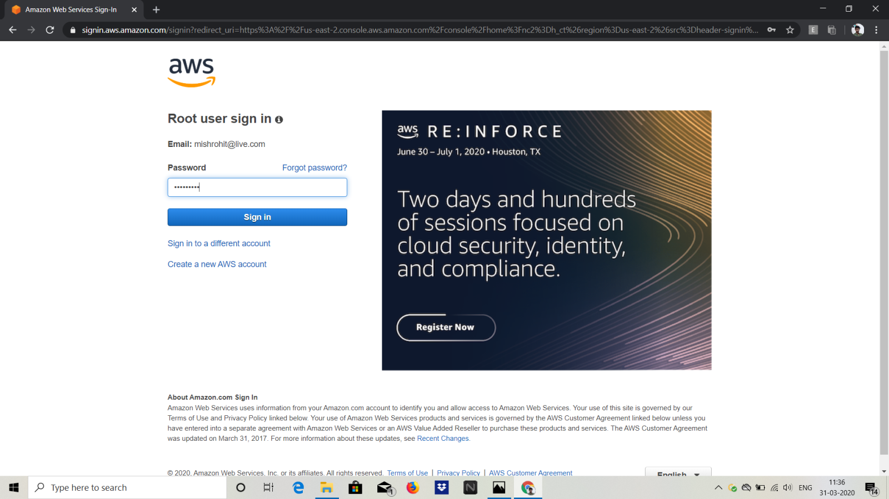

1. EC2 dashboard

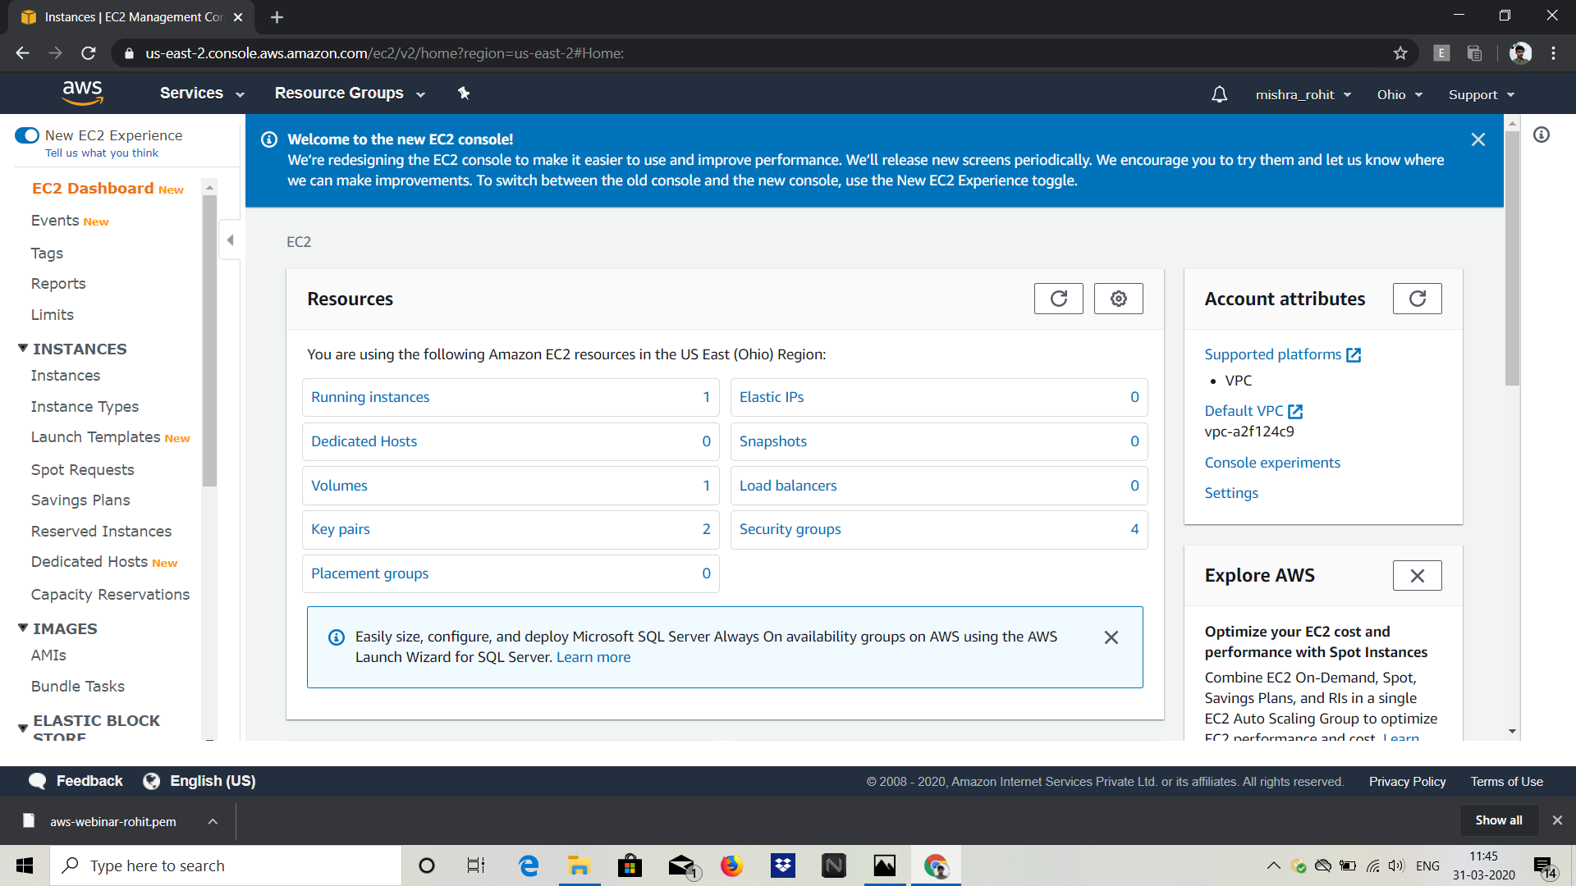

1. S3 Dashboard

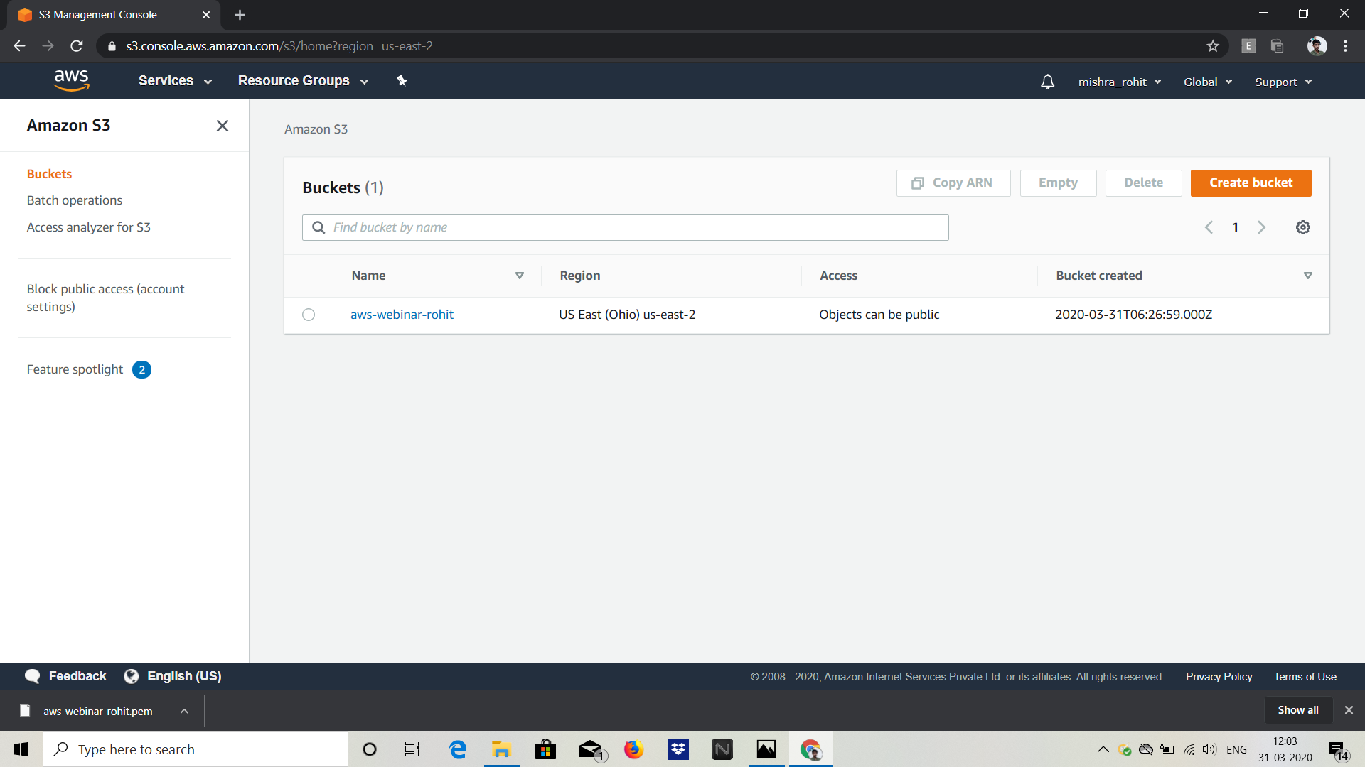

1. Rekognition Dasboard

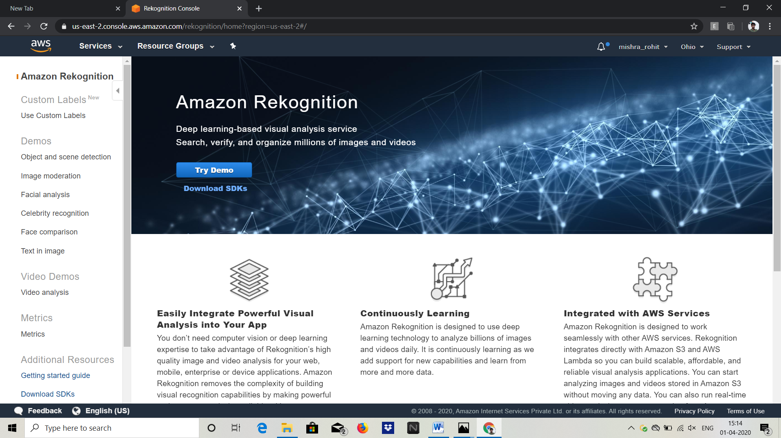

EC2 Screenshots

1. Choosing an AMI

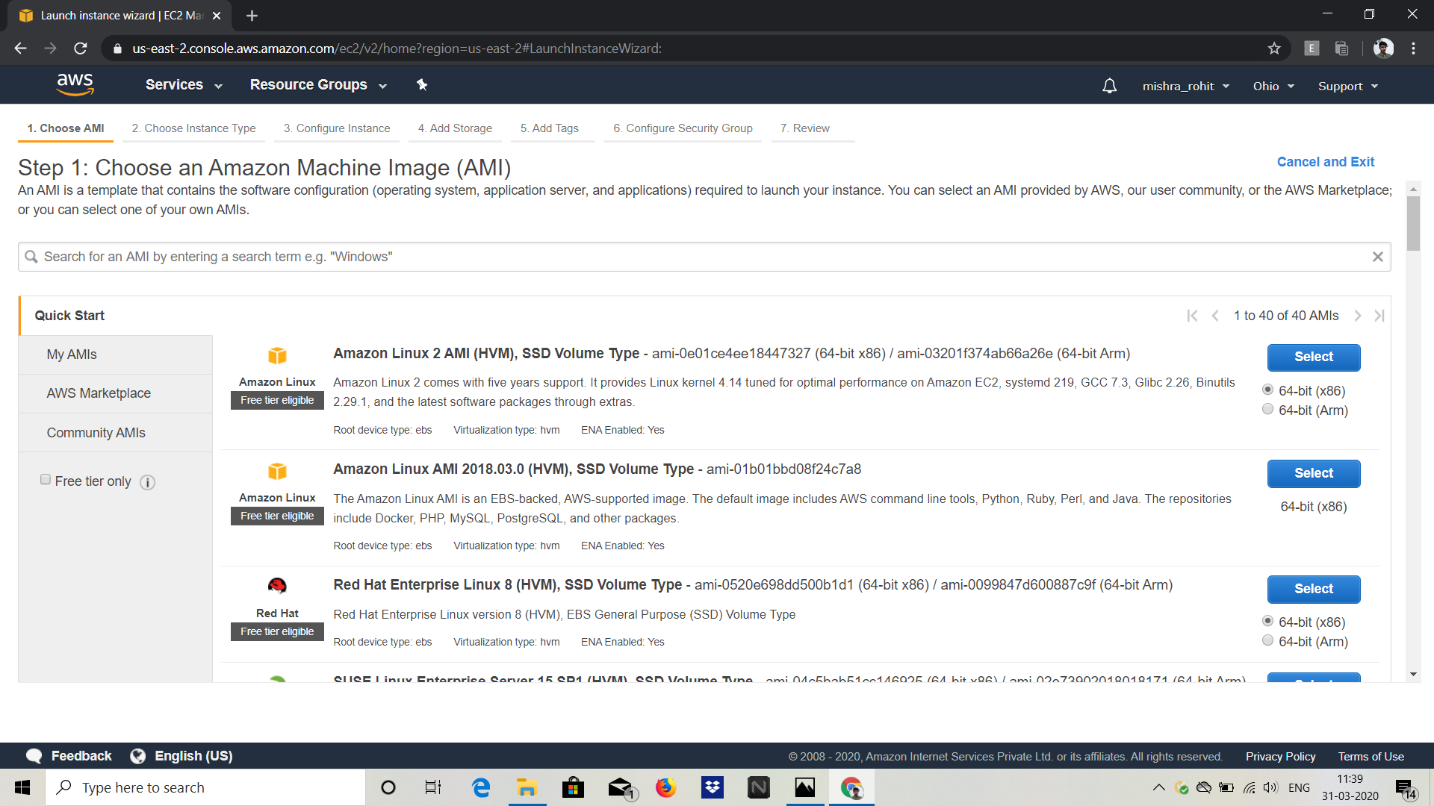

1. Choosing an instance type

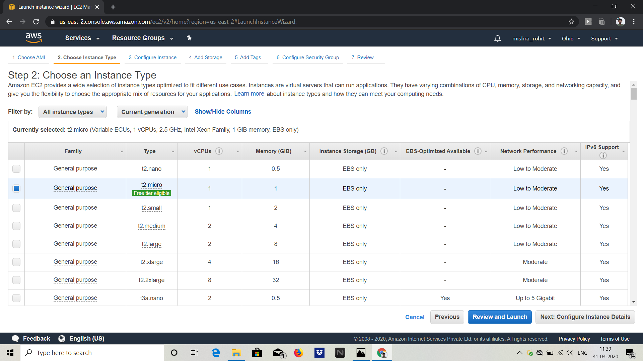

1. Adding Storage

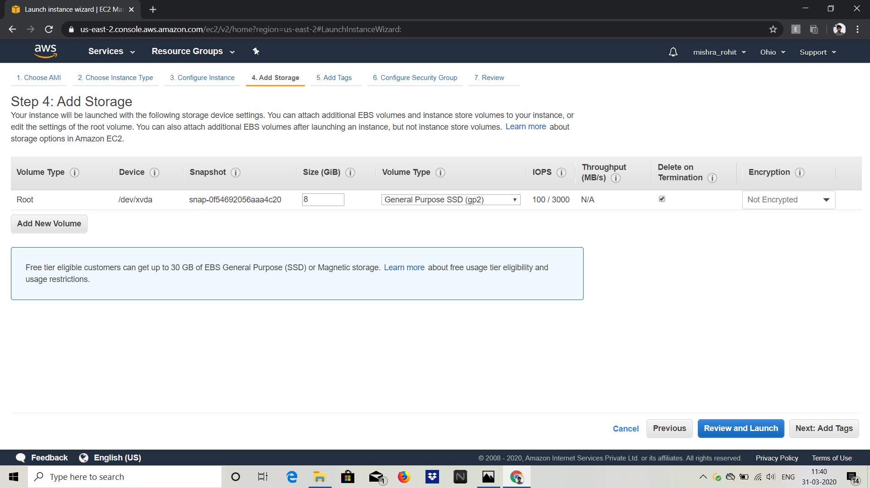

1. Configuring Security Group

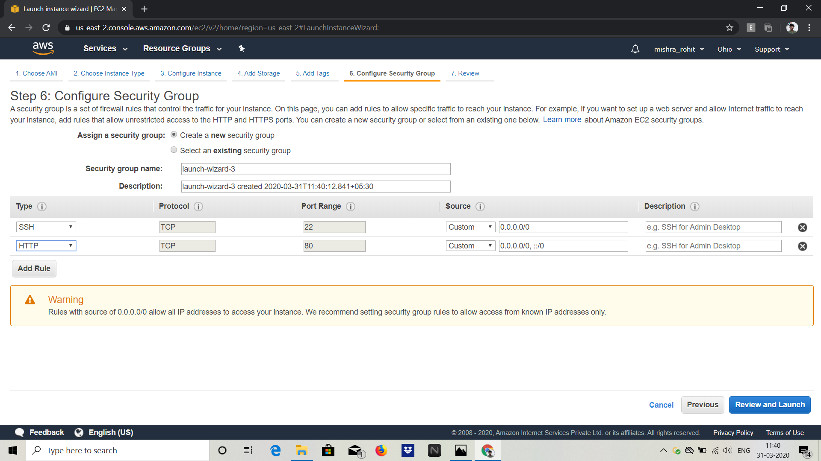

1. Key pair download

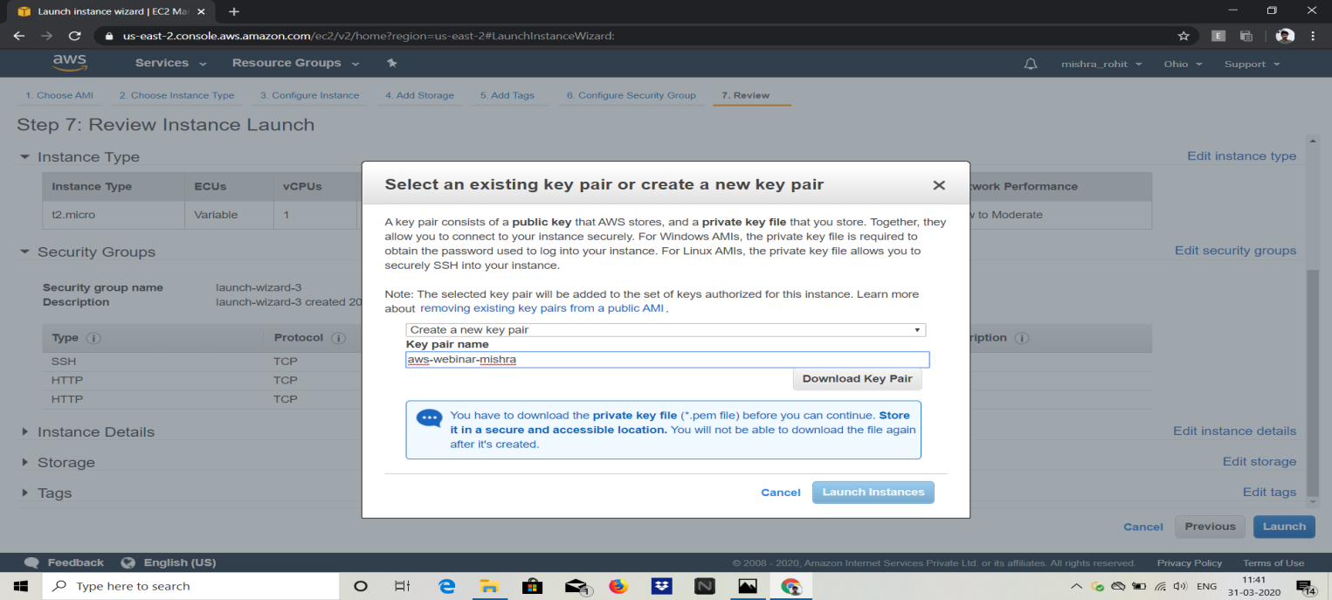

1. PEM to PPK

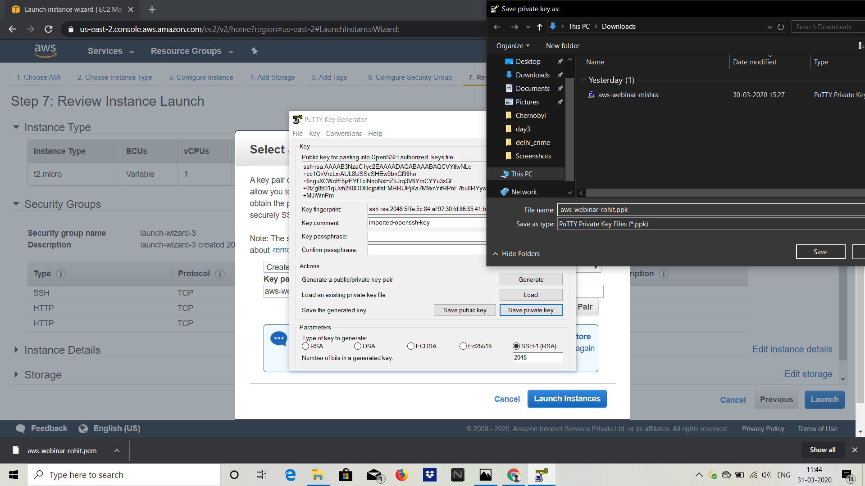

1. Logged into EC2

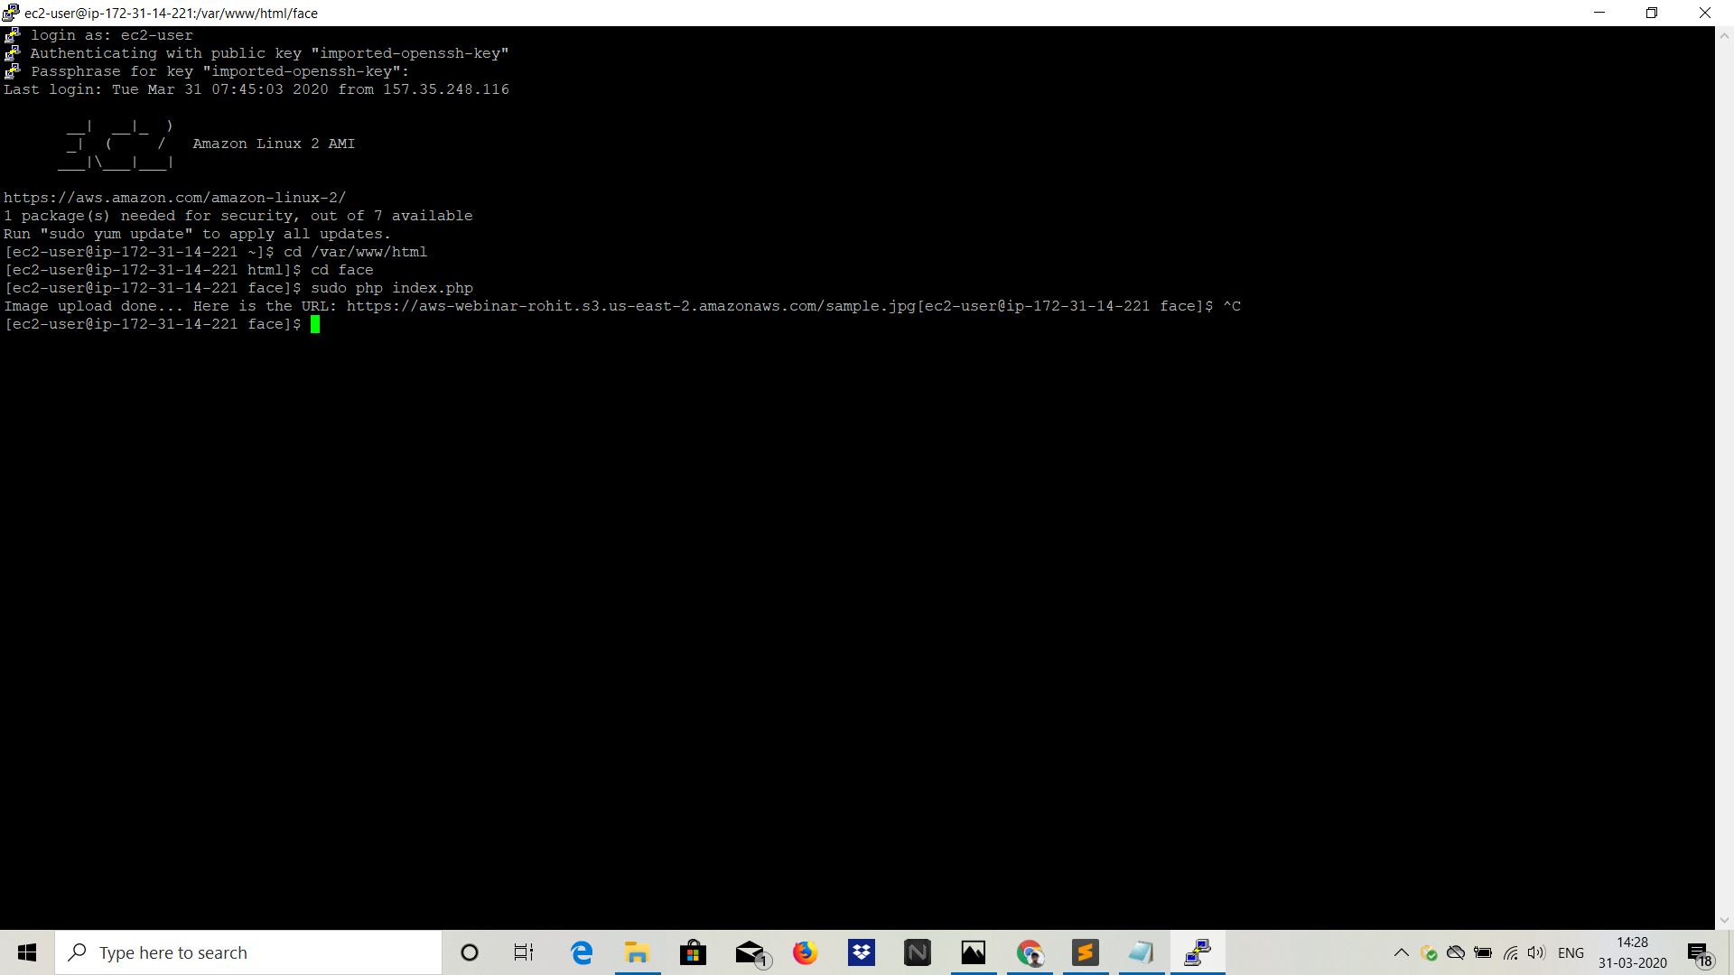

Screenshots for S3

1. Creating a bucket

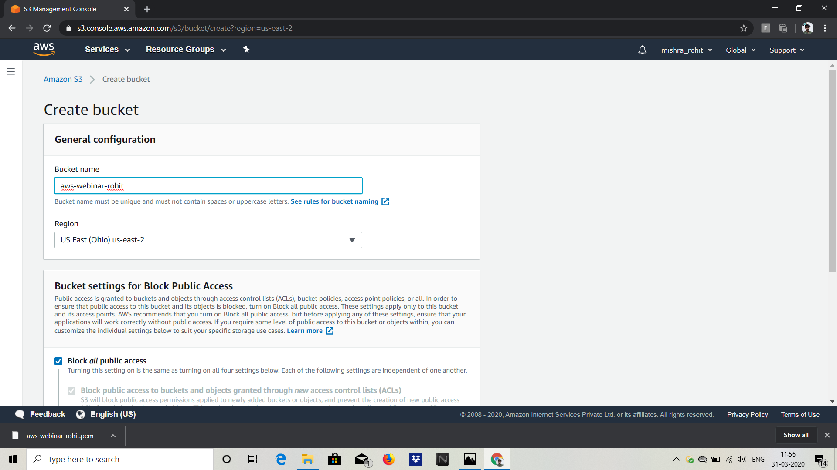

1. Uploading an Object

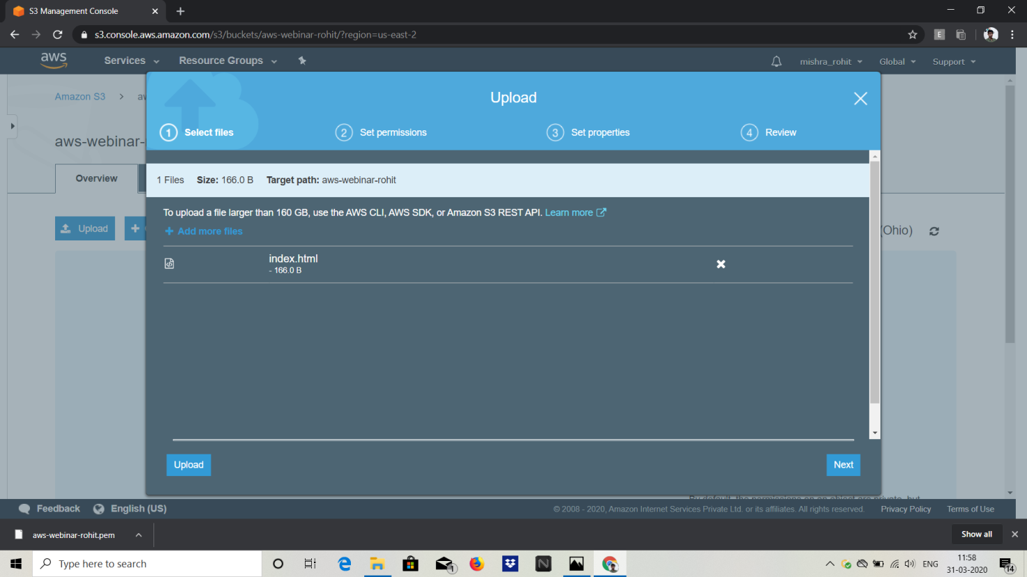

1. Enabling Static Website

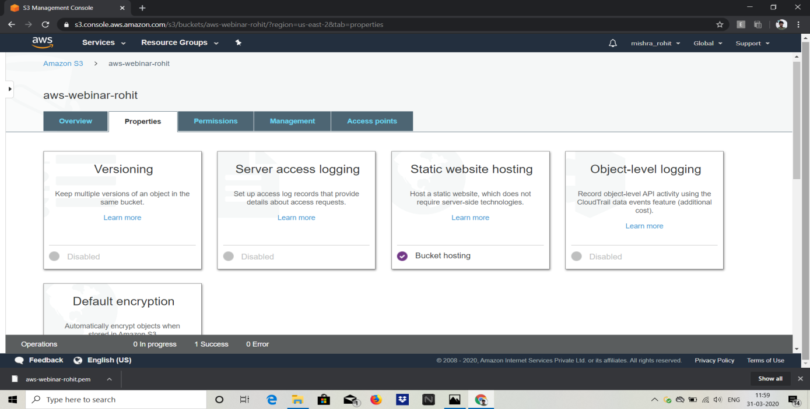

1. Making the object public

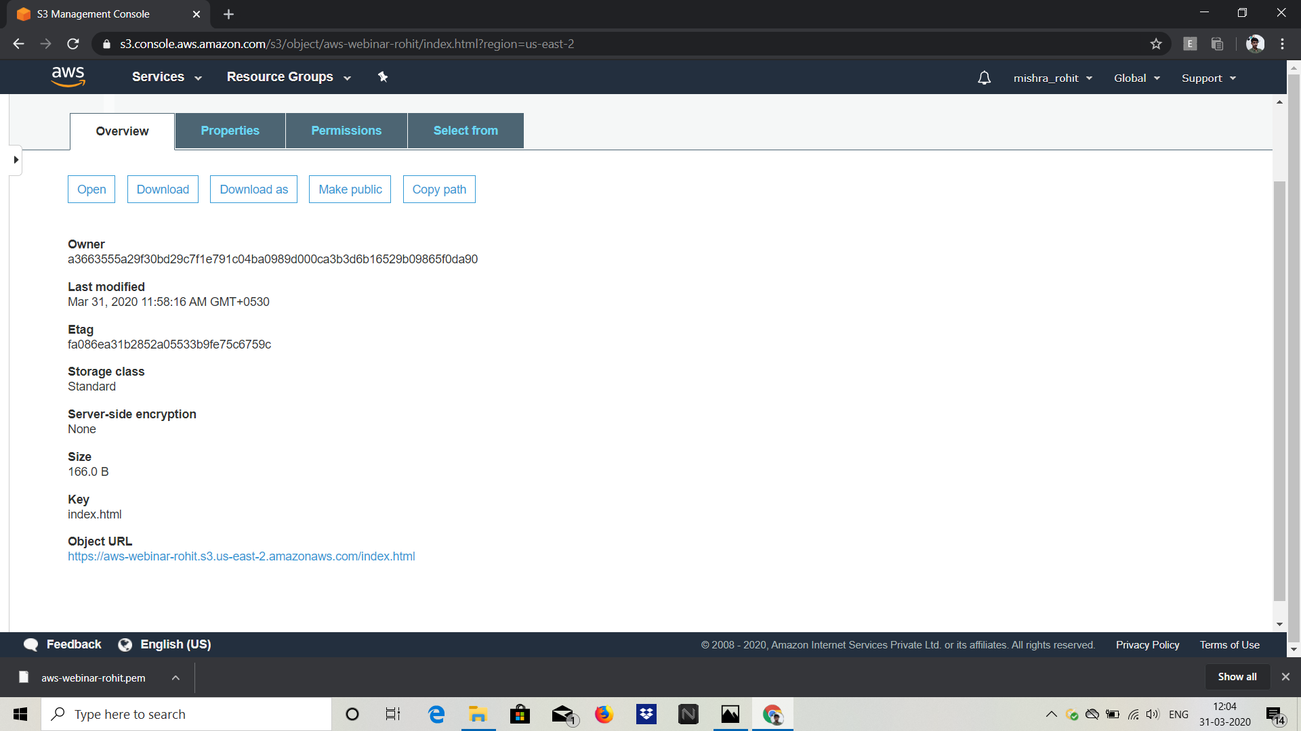

1. Checking the S3 link on browser

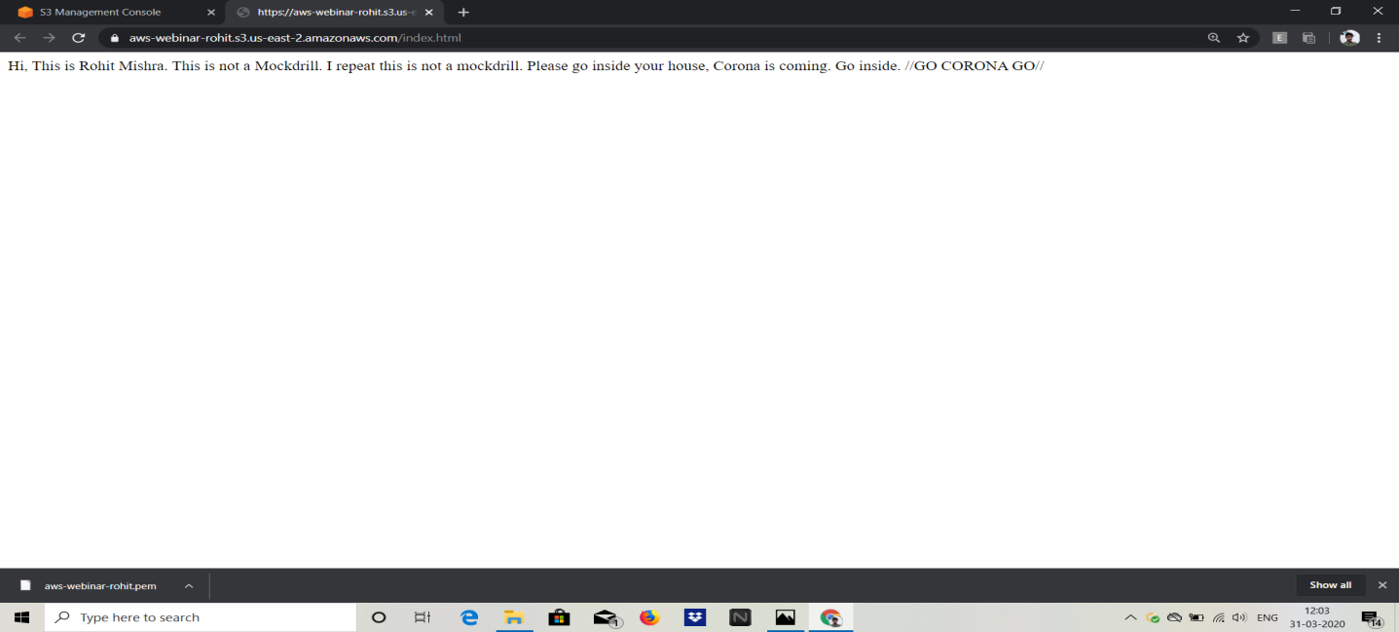

Rekognition

1. Face Detect

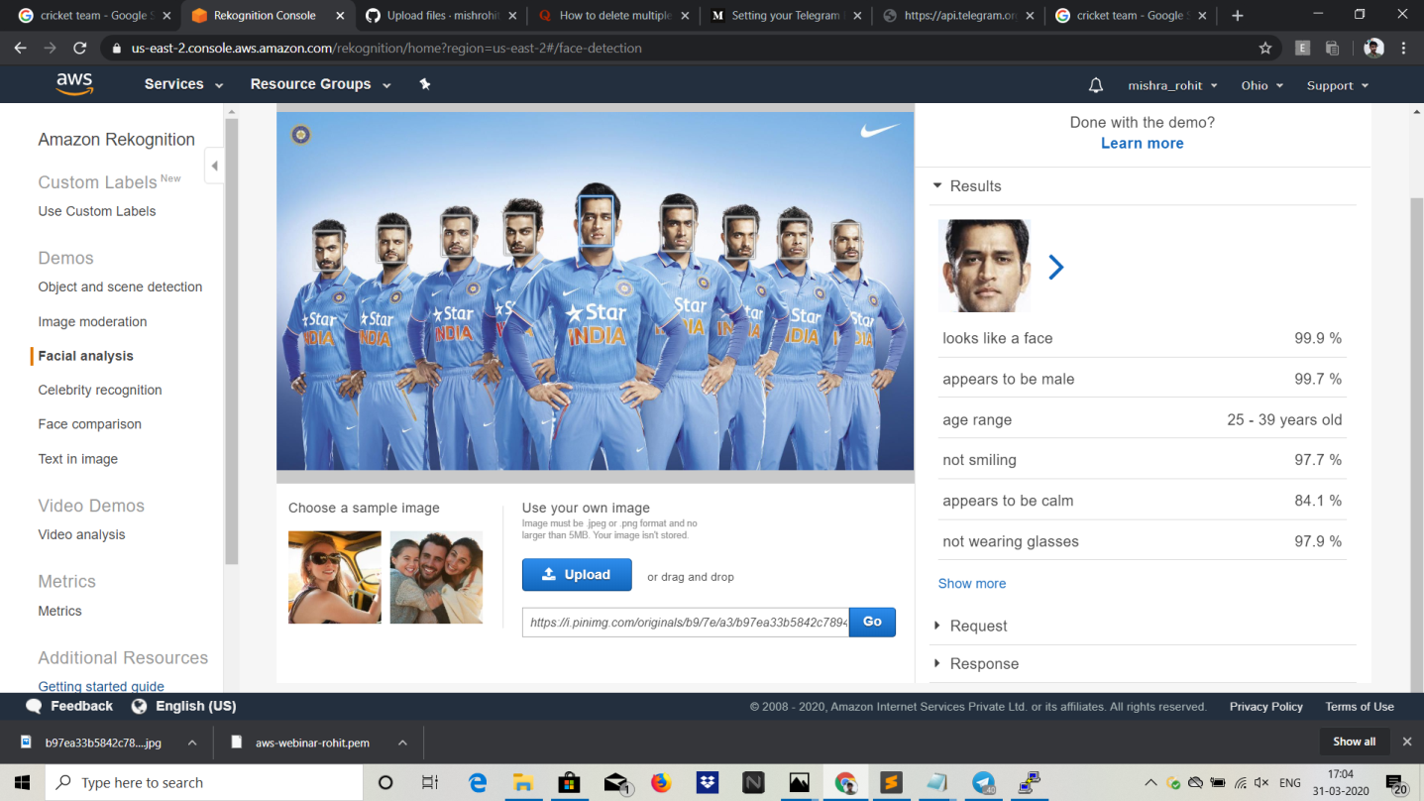

1. Face Compare

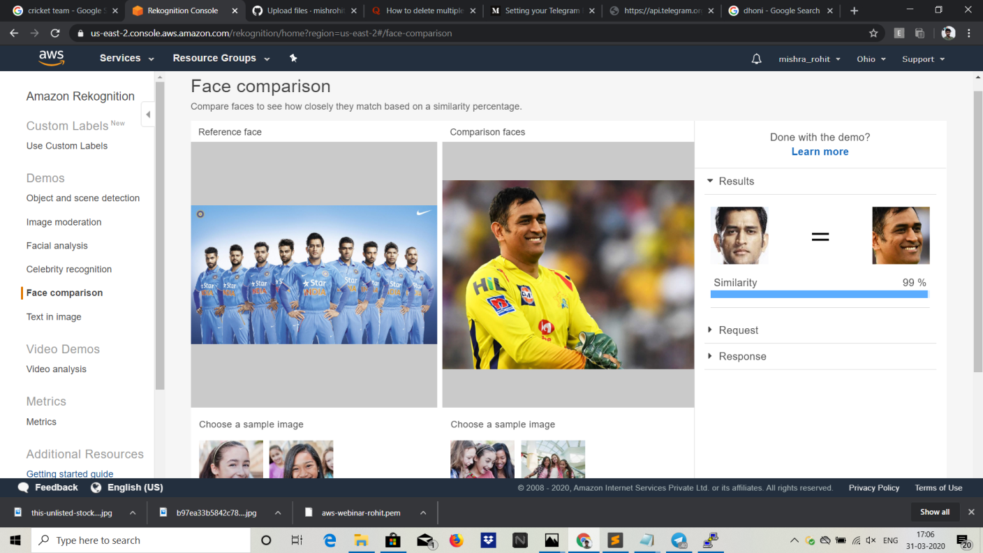

1. Celebrity Rekognition

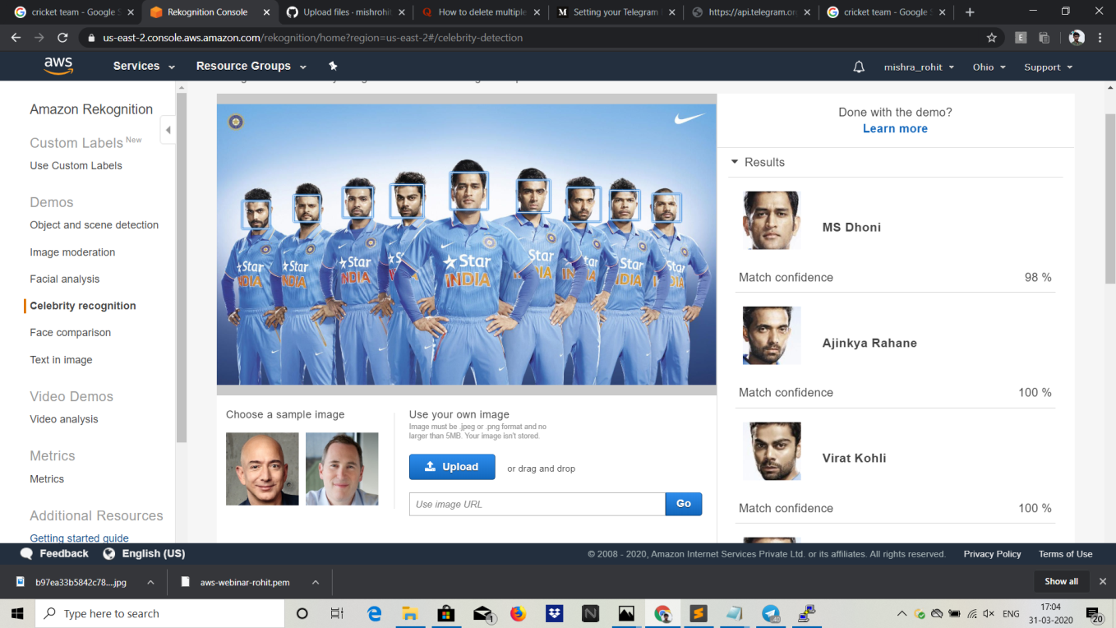

1. Text in Image

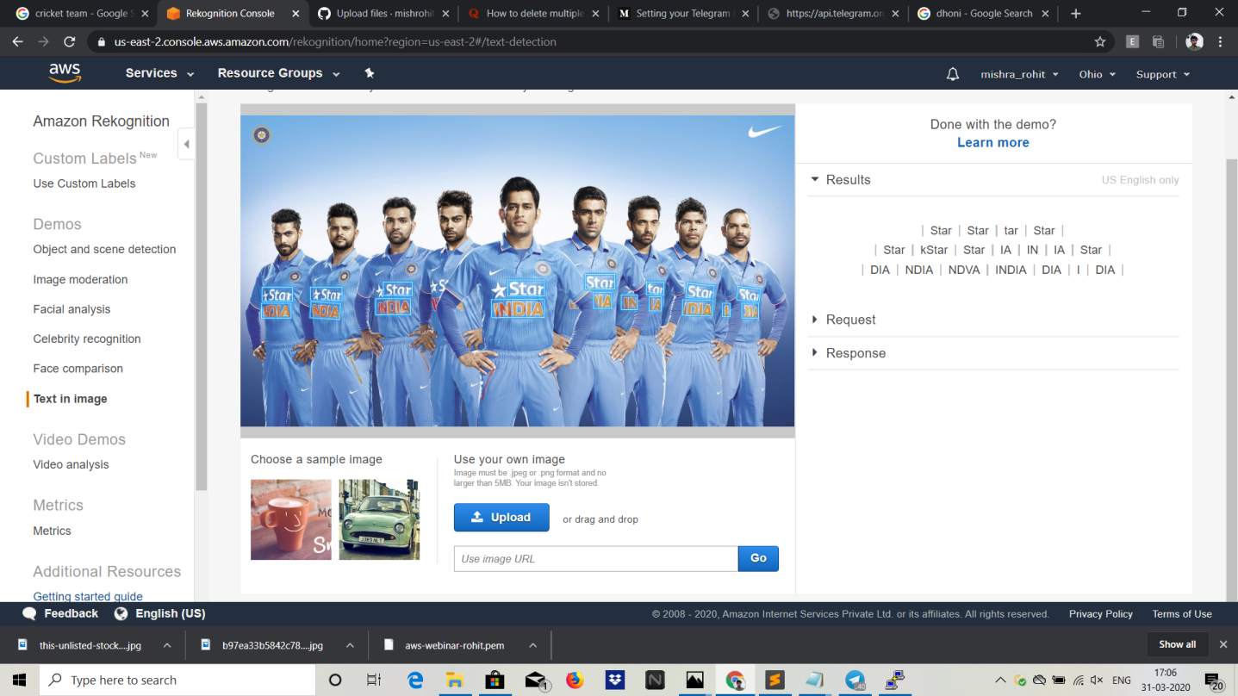

EC2 and S3 integration

1. Installing aws-sdk

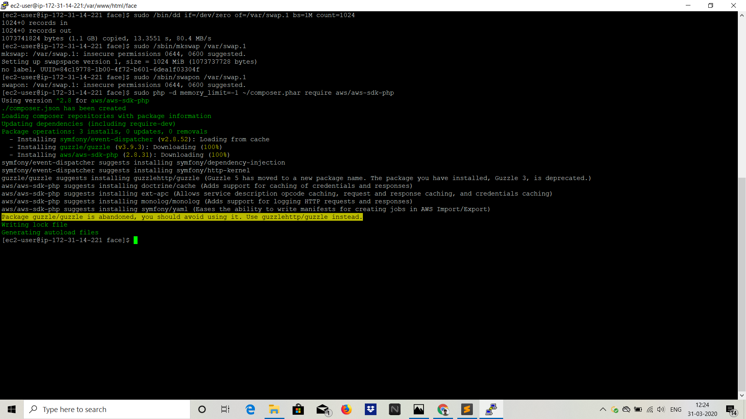

1. Installing PHP

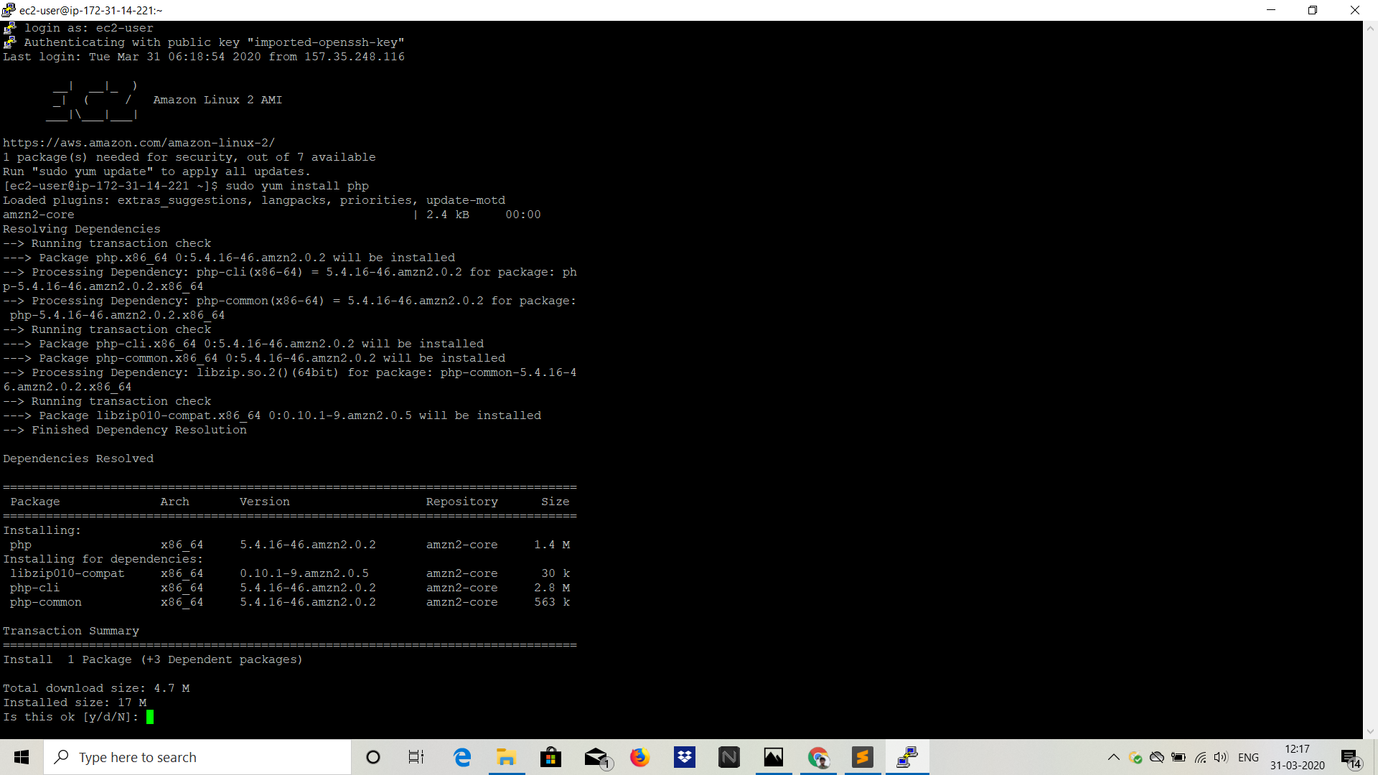

1. Index.php file code

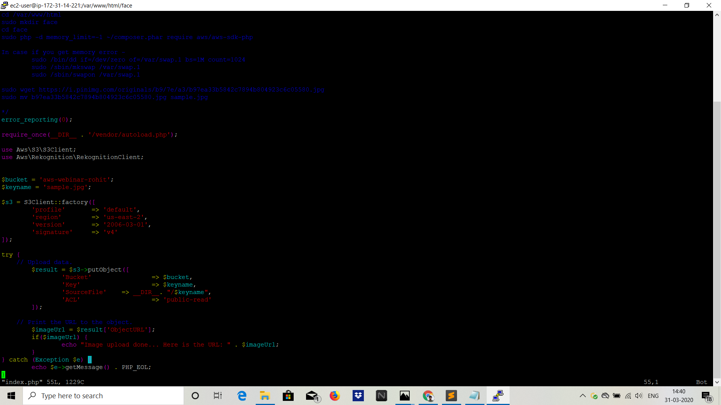

1. Success Screenshot



EC2 and Rekognition

1. Face Detect Success Screenshot

